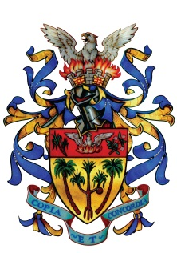

**Venue: Palmerston Municipal Omnisports Complex**

**Registration: From 9 am To 10 am on the same day**

**in collaboration with**

**Tournament reserved for residents of Vacoas/Phoenix only**

**Categories Hommes & Dames**

**Under 15 yrs, Under 18 yrs, Senior, Veteran – Over 40 yrs**

**Mauritius Table Tennis Association**

**Tournament**

**Sunday 05th June 2016 as from 10.00 am**

**MUNICIPAL COUNCIL OF VACOAS-PHOENIX**